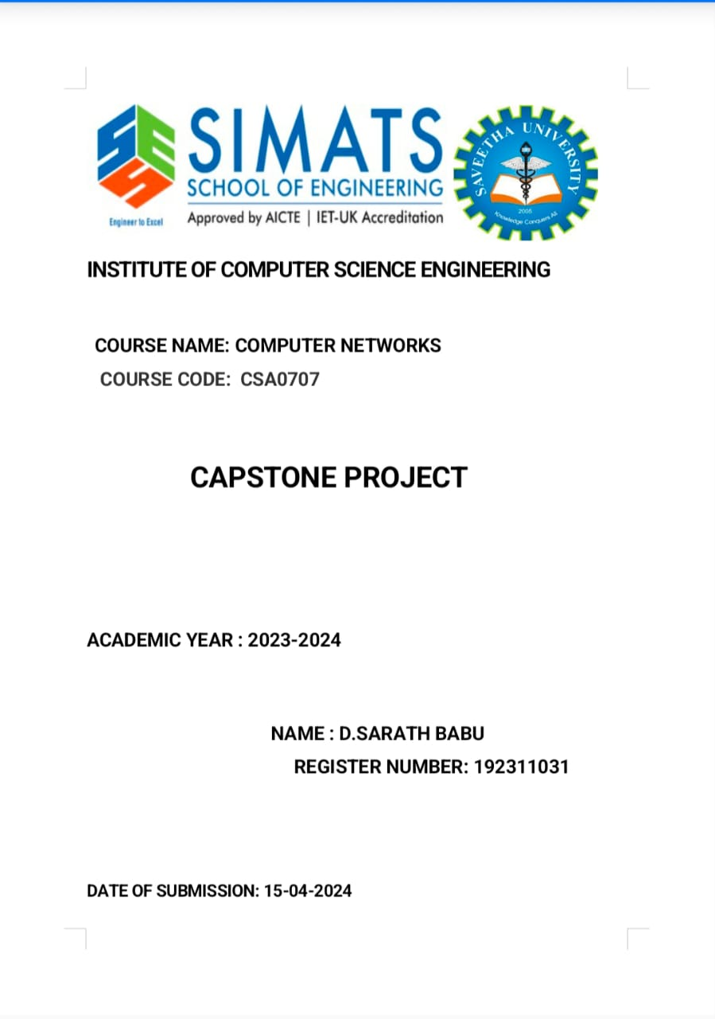

**ENHANCING ONLINE EDUCATION: A LEARNING MANAGEMENT SYSYTEM DEVELOPED THROUGH AGILE METHODOLOGY**

**CAPSTONE PROJECT**

**CSA1086 – SOFTWARE ENGINEERING FOR PROGRAMMING**

**SUBMITTED BY,**

**K. MAYURI – 192372104  
REDDY DORNIYA - 192372061**

**Aim**

The aim of this project is to develop a **Learning Management System (LMS)** using **Agile methodology** to enhance online education by providing a flexible, user-friendly, and feature-rich platform. The system will facilitate efficient course management, student engagement, and progress tracking while ensuring scalability and adaptability to meet the dynamic needs of modern learners and educators.

**Abstract**

In the era of digital education, Learning Management Systems (LMS) have become essential tools for managing and delivering educational content in a structured and accessible manner. This capstone project, titled **“Enhancing Online Education: A Learning Management System Developed Through Agile Practices,”** focuses on designing and implementing an LMS that streamlines course management, facilitates student-instructor interaction, and tracks academic progress efficiently.

To ensure the successful development of the LMS, the **Agile methodology** will be employed, allowing for iterative development, regular feedback, and continuous improvement. By using Agile practices such as **Scrum**, the project will be divided into multiple sprints, where essential features are prioritized, developed, and tested incrementally.

The proposed LMS will include key features such as:

* **Course Management**: Creation and organization of course content.
* **User Roles**: Role-based access for administrators, educators, and students.
* **Progress Monitoring**: Tools for quizzes, assignments, grading, and performance analytics.
* **Interactive Communication**: Features like discussion forums, messaging, and live sessions.
* **Scalability**: The ability to handle growing numbers of users and courses seamlessly.
* **Security and Accessibility**: Ensuring data security and multi-device compatibility.

**Introduction**

The rise of digital technology has revolutionized the education sector, making online learning an essential part of modern education systems. A **Learning Management System (LMS)** serves as a platform to deliver educational content, manage courses, track student performance, and facilitate seamless communication between instructors and learners. With the growing demand for online education, there is a need for LMS platforms that are user-friendly, efficient, and adaptable to the dynamic requirements of learners and educators alike.

To meet this need, this capstone project focuses on developing an **Online Learning Management System** using the **Agile methodology**. Agile practices, particularly frameworks like **Scrum**, allow for an iterative development approach where features are prioritized, developed, and delivered in small increments. This ensures that the system remains adaptable, scalable, and responsive to feedback throughout the development lifecycle.

The proposed LMS will incorporate critical features such as **course management**, **user roles**, **progress monitoring**, **interactive communication**, and **scalability**. Educators can create and manage courses effectively, while students can engage with the content, submit assignments, and track their academic progress. Additionally, built-in communication tools will ensure continuous interaction between teachers and students, replicating the collaborative nature of traditional classrooms in an online environment.

The **Agile methodology** ensures that user needs and expectations are addressed in real time, with a focus on delivering a high-quality product through iterative development and continuous feedback. By adopting Agile practices, this project will deliver a **feature-rich, secure, and scalable LMS** that can support educational institutions in their digital transformation and enhance the learning experience for students.

This introduction sets the stage for a comprehensive LMS that not only meets the current demands of online education but also evolves continuously to address future challenges and advancements in the digital learning landscape.

**Project Overview**

This capstone project, **“Enhancing Online Education: A Learning Management System Developed Through Agile Practices,”** focuses on creating an LMS that addresses key challenges in online education, such as user engagement, course management, and performance tracking. The goal is to design a scalable and user-friendly platform that enhances the quality of online education by implementing features tailored to meet the needs of modern learners and instructors.

The key objectives of the project include:

* Developing a platform that simplifies course creation, delivery, and assessment.
* Ensuring real-time interaction between educators and students through interactive features like forums, chat, and live sessions.
* Providing robust tools for progress tracking, such as assignments, quizzes, and grade reports.
* Incorporating a user-friendly interface to maximize adoption and ease of use.
* Supporting scalability to accommodate a growing number of courses and users over time.

**Why Agile Methodology?**

The Agile methodology is particularly suitable for developing an **Online Learning Management System (LMS)** due to its flexibility, iterative nature, and focus on user satisfaction. Unlike traditional software development methods, Agile emphasizes **incremental delivery**, **collaboration**, and **adaptability**, which are essential when building systems with dynamic and evolving requirements. Below are the key reasons why Agile methodology is ideal for this project:

**1. Iterative Development**

Agile breaks down the project into smaller, manageable iterations (sprints), allowing the development team to build the LMS incrementally. Each sprint delivers a specific set of features, ensuring continuous progress and early validation of functionalities.

* **For Example**: In the first sprint, the system may focus on user authentication and role management. In the next sprint, course management and progress tracking features can be added. This approach ensures that the system is developed in phases, making it easier to manage and test.

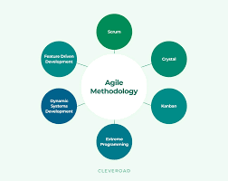

**2. Flexibility and Adaptability**

The Agile methodology allows changes to be incorporated at any stage of development based on user feedback or evolving project requirements. This is particularly important for LMS development, where features such as user experience, course content delivery, and communication tools need to adapt to user needs.

* **For Example**: If feedback indicates that a messaging feature between instructors and students needs improvement, it can be addressed immediately in the next sprint without disrupting the overall project timeline.

**3. Focus on User Feedback**

Agile encourages constant communication with stakeholders, including instructors, students, and administrators, to gather feedback and prioritize features. This user-centric approach ensures the final system aligns with real-world needs and expectations.

* **Benefit**: By regularly involving end users, the team can identify issues early and deliver an LMS that provides a seamless learning experience.

**4. Faster Delivery of Working Software**

Agile ensures that working components of the LMS are delivered at the end of each sprint. This allows stakeholders to see progress and use partially completed features while the remaining components are being developed.

* **Benefit**: Organizations can begin utilizing essential LMS features earlier, even before the full system is complete, improving overall productivity.

**5. Enhanced Collaboration**

Agile promotes team collaboration through daily stand-ups, sprint reviews, and retrospectives. Regular communication among developers, testers, and stakeholders ensures transparency, quick issue resolution, and alignment with project goals.

* **Benefit**: This collaborative environment improves the quality of the LMS and ensures all team members remain aligned on the project vision.

**6. Risk Management**

Agile minimizes project risks by delivering features incrementally and validating them through continuous testing. This reduces the likelihood of large-scale failures at the end of development and allows early identification of potential challenges.

* **For Example**: If a specific feature, such as file submission for assignments, poses technical issues, it can be identified and resolved in one sprint before moving to the next.

**7. Scalability and Continuous Improvement**

Agile facilitates the development of scalable systems by allowing for iterative enhancements. As the needs of educational institutions grow, new features or improvements can be seamlessly integrated into the LMS without disrupting the existing functionalities.

* **For Example**: Advanced features like AI-based learning recommendations or real-time analytics can be added to the system incrementally over time.

**8. Customer Satisfaction**

The Agile methodology ensures a higher degree of satisfaction for end users. By delivering functional software in increments and adapting to feedback, Agile guarantees that the final LMS meets the expectations of educators, students, and administrators.

* **Benefit**: A user-friendly, efficient, and feature-rich LMS enhances the overall online learning experience.

**Importance of Learning Management Systems (LMS) in Online Education:**

Learning Management Systems (LMS) have revolutionized the education sector, particularly in the online learning environment. They serve as a centralized platform to manage, deliver, and track educational content while enhancing accessibility, engagement, and efficiency. In today’s digital age, the role of an LMS in online education cannot be overstated due to the following key aspects:

**1. Centralized Learning Platform**

An LMS acts as a single, unified platform for organizing all learning materials, including video lectures, course notes, assignments, quizzes, and resources. This makes it easier for both educators and students to access relevant content anytime, anywhere.

* **Benefit**: Educators can efficiently organize resources, and students can retrieve them without confusion or delays.

**2. Flexibility and Accessibility**

LMS platforms allow students to access course materials at their convenience, enabling self-paced learning. Learners can study at their own speed and revisit lessons as needed, making education accessible to students across time zones and geographies.

* **Benefit**: Individuals balancing education with work, family, or other commitments can study without disruption.

**3. Enhanced Student Engagement**

Interactive features of an LMS, such as discussion forums, quizzes, and gamification tools, enhance student engagement. Features like real-time chat and video conferencing make online education more interactive, replicating a classroom-like experience.

* **Benefit**: Students actively participate in discussions and activities, improving knowledge retention and learning outcomes.

**4. Effective Course Management**

LMS platforms help instructors create, manage, and update courses easily. With built-in features to schedule lessons, assign tasks, and grade assessments, LMS simplifies administrative processes.

* **Benefit**: Educators can focus more on teaching rather than dealing with manual, time-consuming tasks.

**5. Tracking and Reporting**

An LMS provides tools to monitor student progress through assessments, attendance tracking, and performance analytics. Instructors can generate reports to identify areas where students excel or struggle.

* **Benefit**: Timely feedback allows educators to adjust teaching strategies, and students can identify their strengths and weaknesses.

**6. Scalability and Cost-Effectiveness**

LMS platforms can accommodate a large number of learners simultaneously, making them highly scalable. By reducing infrastructure and operational costs (e.g., physical classrooms, printed materials), LMS makes education more cost-effective.

* **Benefit**: Institutions can reach more learners globally without incurring additional expenses.

**7. Seamless Integration with Modern Tools**

Modern LMS platforms integrate with tools such as video conferencing applications, plagiarism checkers, and cloud storage systems. They also support multimedia content like videos, animations, and podcasts.

* **Benefit**: This enhances the quality of education and caters to diverse learning styles, making learning more engaging and accessible.

**8. Personalization of Learning**

An LMS enables personalized learning paths for students based on their performance, interests, and pace of learning. Adaptive learning tools can deliver customized content to cater to individual needs.

* **Benefit**: Students receive a tailored educational experience, helping them learn more effectively.

**9. Remote Collaboration**

LMS platforms facilitate collaboration among students and instructors through tools such as shared documents, group projects, and virtual classrooms. This fosters teamwork and communication skills.

* **Benefit**: Remote learners feel connected and supported, enhancing their overall learning experience.

**10. Reliable Assessment and Certification**

LMS systems support various assessment tools, including quizzes, assignments, and tests. They also automate grading and provide certification upon course completion.

* **Benefit**: Students can easily demonstrate their achievements, and institutions can ensure fair evaluation processes.

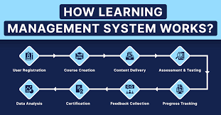

**Key Features:**

The proposed LMS is designed to cater to the needs of modern online education, ensuring accessibility, engagement, and efficiency for both learners and educators. Below are the key features that set this LMS apart and address the critical requirements of online learning environments:

**1. User-Friendly Interface**

* **Feature**: The LMS has an intuitive and easy-to-navigate interface for students, teachers, and administrators.
* **Benefit**: Users can access resources, track progress, and manage courses without requiring technical expertise.

**2. Multi-Device Accessibility**

* **Feature**: The system is fully responsive and accessible on desktops, tablets, and smartphones.
* **Benefit**: Students and educators can learn and teach on-the-go, making learning flexible and location-independent.

**3. Course Management**

* **Feature**: Teachers can create, organize, and manage courses with modules that include video lectures, assignments, quizzes, and reference materials.
* **Benefit**: Simplifies content delivery and reduces administrative overhead for instructors.

**4. Personalized Learning Paths**

* **Feature**: The LMS provides adaptive learning paths based on students’ progress, interests, and assessment results.
* **Benefit**: Ensures that students receive a customized learning experience tailored to their needs.

**5. Interactive Content Delivery**

* **Feature**: Supports multimedia content like video lectures, presentations, e-books, podcasts, and interactive quizzes.
* **Benefit**: Enhances engagement and caters to diverse learning styles, making learning more effective.

**6. Assessment and Evaluation**

* **Feature**: Includes automated tools for creating quizzes, assignments, and exams with features like grading, feedback, and report generation.
* **Benefit**: Provides real-time feedback to students and simplifies the evaluation process for educators.

**7. Progress Tracking and Analytics**

* **Feature**: The system tracks student progress through dashboards, performance analytics, and detailed reports.
* **Benefit**: Enables educators to identify learning gaps and allows students to monitor their own progress.

**8. Discussion Forums and Collaboration Tools**

* **Feature**: Facilitates interaction among students and instructors via discussion forums, live chat, and virtual classrooms.
* **Benefit**: Promotes collaborative learning and improves communication among users.

**9. Secure Authentication and Role-Based Access**

* **Feature**: Implements secure login mechanisms with role-based access (e.g., student, teacher, admin) to ensure data security.
* **Benefit**: Protects sensitive information and provides different levels of access for different user roles.

**10. Integration with Third-Party Tools**

* **Feature**: Integrates with video conferencing tools (e.g., Zoom, Google Meet), plagiarism checkers, and cloud storage services.
* **Benefit**: Enhances the learning experience by incorporating modern tools and technologies.

**11. Notification and Alerts System**

* **Feature**: Provides automated notifications for deadlines, exam dates, course updates, and feedback.
* **Benefit**: Keeps students informed and engaged, helping them manage their tasks effectively.

**12. Gamification for Motivation**

* **Feature**: Incorporates elements like badges, rewards, and leaderboards to encourage student participation and motivation.
* **Benefit**: Makes learning fun, competitive, and engaging, improving student retention rates.

**13. Content Management System**

* **Feature**: Allows educators to upload, edit, and organize educational resources such as course materials, videos, and assessments.
* **Benefit**: Simplifies content delivery and ensures all resources are centrally available.

**14. Attendance Management**

* **Feature**: Tracks attendance for live classes and logs user activity on the platform.
* **Benefit**: Allows administrators to monitor student participation and engagement.

**15. Data Backup and Recovery**

* **Feature**: Includes automatic data backup and recovery features to ensure no loss of user data.
* **Benefit**: Provides reliability and minimizes disruptions due to technical failures.

**16. Scalability**

* **Feature**: Designed to accommodate increasing numbers of students, teachers, and courses as demand grows.
* **Benefit**: Ensures the LMS remains efficient and responsive as user numbers scale up.

**17. Certification and Reporting**

* **Feature**: Generates course completion certificates and provides performance reports for students and instructors.
* **Benefit**: Encourages students by validating their learning outcomes and providing a sense of achievement.

**18. Secure Payment Gateway**

* **Feature**: Integrates secure payment systems for course enrollment and subscriptions.
* **Benefit**: Facilitates smooth financial transactions while ensuring user security and trust.

**Agile Implementation Process:**

The Agile methodology ensures iterative development, collaboration, and continuous improvement during the LMS implementation. Below is a step-by-step breakdown of the Agile implementation process for this project:

**1. Project Initiation and Requirement Gathering**

* **Objective**: Identify and document the requirements for the LMS.
* **Activities**:
  + Conduct meetings with stakeholders (teachers, students, admins) to gather user requirements.
  + Develop a **Product Backlog** that includes features such as course management, assessments, user dashboards, and collaboration tools.
  + Prioritize user stories based on business value and user needs.
* **Outcome**: A clear and prioritized product backlog to guide development.

**2. Sprint Planning**

* **Objective**: Break the product backlog into smaller tasks and define the deliverables for the first sprint.
* **Activities**:
  + Define the **Sprint Goal**.
  + Break down high-priority user stories into smaller tasks.
  + Assign tasks to the development team based on capacity and skill.
  + Establish a time-boxed sprint duration (e.g., 2–4 weeks).
* **Outcome**: A sprint backlog outlining specific tasks and goals for the sprint.

**3. Design and Prototyping**

* **Objective**: Create designs for the LMS interface and system architecture.
* **Activities**:
  + Develop wireframes and UI/UX prototypes for key features.
  + Design the system architecture, including database design and integration points.
  + Validate the prototypes with stakeholders for feedback.
* **Outcome**: Approved design and architecture that align with user expectations.

**4. Iterative Development (Sprints)**

* **Objective**: Incrementally build and deliver functional features of the LMS.
* **Activities**:
  + Code, test, and implement features such as:
    - **User Management**: Registration, login, and role-based access.
    - **Course Management**: Creation and organization of courses.
    - **Assessment Module**: Quizzes, assignments, and grading tools.
    - **Collaboration Tools**: Discussion forums and chat systems.
  + Conduct **Daily Standup Meetings** to monitor progress and resolve issues.
  + Perform continuous integration to ensure that the codebase remains stable.
* **Outcome**: A working increment of the LMS at the end of each sprint.

**5. Testing and Quality Assurance**

* **Objective**: Ensure the LMS meets user requirements and functions seamlessly.
* **Activities**:
  + Conduct different levels of testing:
    - **Unit Testing**: Test individual components of the LMS.
    - **Integration Testing**: Verify the interaction between different modules.
    - **System Testing**: Test the overall LMS functionality.
    - **User Acceptance Testing (UAT)**: Validate the LMS with end-users.
  + Address bugs and implement feedback from testing.
* **Outcome**: A reliable and high-quality LMS with minimal errors.

**6. Sprint Review and Feedback**

* **Objective**: Present the completed sprint deliverables to stakeholders for feedback.
* **Activities**:
  + Demonstrate the working features to stakeholders.
  + Gather feedback and suggestions for improvement.
  + Update the product backlog with new user stories based on stakeholder input.
* **Outcome**: Improved understanding of stakeholder requirements and a refined product backlog.

**7. Sprint Retrospective**

* **Objective**: Reflect on the sprint process and identify areas for improvement.
* **Activities**:
  + Team discusses what went well, challenges faced, and opportunities for improvement.
  + Document lessons learned and adjust processes for the next sprint.
* **Outcome**: Enhanced team performance and improved efficiency in the upcoming sprints.

**8. Deployment and Release**

* **Objective**: Deploy the LMS to a production environment for end-user access.
* **Activities**:
  + Perform final system testing in a staging environment.
  + Deploy the LMS to the production server.
  + Monitor the LMS performance and resolve any deployment issues.
  + Train end-users (students, teachers, and admins) on how to use the LMS effectively.
* **Outcome**: Fully deployed LMS accessible to users with all core functionalities.

**9. Continuous Improvement**

* **Objective**: Continuously enhance the LMS based on user feedback and evolving requirements.
* **Activities**:
  + Collect user feedback through surveys, analytics, and support channels.
  + Identify new features or improvements to add to the product backlog.
  + Release updates through regular sprints for ongoing refinement.
* **Outcome**: A dynamic and scalable LMS that adapts to changing user needs and technology trends.

**Output:**

In the context of enhancing online education, a Learning Management System (LMS) developed through Agile practices would focus on iterative and incremental development. Using Agile methodologies, the LMS can continuously improve through feedback loops and user stories, ensuring that the platform adapts to the changing needs of educators, students, and administrators.

1. **Frequent Updates**: Agile allows for frequent updates and releases, meaning new features, improvements, or bug fixes can be rolled out quickly.
2. **Customization**: The LMS can be easily tailored to specific needs of institutions by developing features based on real user feedback.
3. **Enhanced Collaboration**: Agile promotes collaboration between developers, educators, and users. This leads to a more user-centric design and better alignment with real-world teaching and learning needs.
4. **Faster Problem Solving**: Problems can be identified and addressed in real time, enhancing the overall user experience for both students and instructors.
5. **Scalable Solutions**: The Agile approach allows the LMS to scale effectively, accommodating growing numbers of students and new educational methods.

**Conclusion:**

Agile practices offer significant advantages when developing an LMS for online education. The iterative nature of Agile allows for continuous improvement based on stakeholder feedback, leading to a highly functional and adaptable system. By adopting Agile practices, educational institutions can ensure their LMS remains responsive to the evolving needs of both learners and educators, ultimately enhancing the quality and accessibility of online education. This approach fosters better collaboration, faster issue resolution, and a product that aligns more closely with the educational goals of users.